The Ohio State University

Colleges of the Arts and Sciences New Course Request

Department of Geological Sciences

Academic Unit
Geological Sciences

Book 3 Listing (e.g., Portuguese)
421 Peak Oil and Sustainability
Number Title
Peak Oil and Sustain. U 05
18-Character Title Abbreviation Level Credit Hours

Summer Autumn Winter X Spring Year 2007
Proposed effective date, choose one quarter and put an “X” after it; and fill in the year. See the OAA curriculum manual for deadlines.

A. Course Offerings Bulletin Information

Follow the instructions in the OAA curriculum manual. If this is a course with decimal subdivisions, then use one New Course Request form for the generic information that will apply to all subdivisions; and use separate forms for each new decimal subdivision, including on each form the information that is unique to that subdivision. If the course offered is less than a quarter or a term, please complete the Flexibly Scheduled/Off Campus/Workshop Request form.

Description (not to exceed 25 words): An examination of the problem of decreasing supplies of fossil fuel,

alternative energy sources, and possible accommodations.

Quarter offered: Winter Distribution of class time/contact hours: 2, 2-hr lectures and 1, 1-hr recitation/wk
Quarter and contact/class time hours information should be omitted from Book 3 publication (yes or no): No

Prerequisite(s): GEC data analysis course; sophomore standing and above

Exclusion or limiting clause:

Repeatable to a maximum of __NA__ credit hours.

Cross-listed with:

Grade Option (Please check): Letter X S/U Progress What is course is last in the series? ______

Honors Statement: Yes No X GEC: Yes No X Admission Condition
Off-Campus: Yes No X EM: Yes No X Course: Yes No X

Other General Course Information:
(e.g. “Taught in English.” “Credit does not count toward BSBA degree.”)

B. General Information

Subject Code________________________ Subsidy Level (V, G, T, B, M, D, or P)___________________________
If you have questions, please email Jed Dickhaut at dickhaut.1@osu.edu.

1. Provide the rationale for proposing this course:
See Attached

2. Please list Majors/Minors affected by the creation of this new course. Attach revisions of all affected programs. This course is (check one): Required on major(s)/minor(s) XA choice on major(s)/minors(s)
An elective within major(s)/minor(s) A general elective:

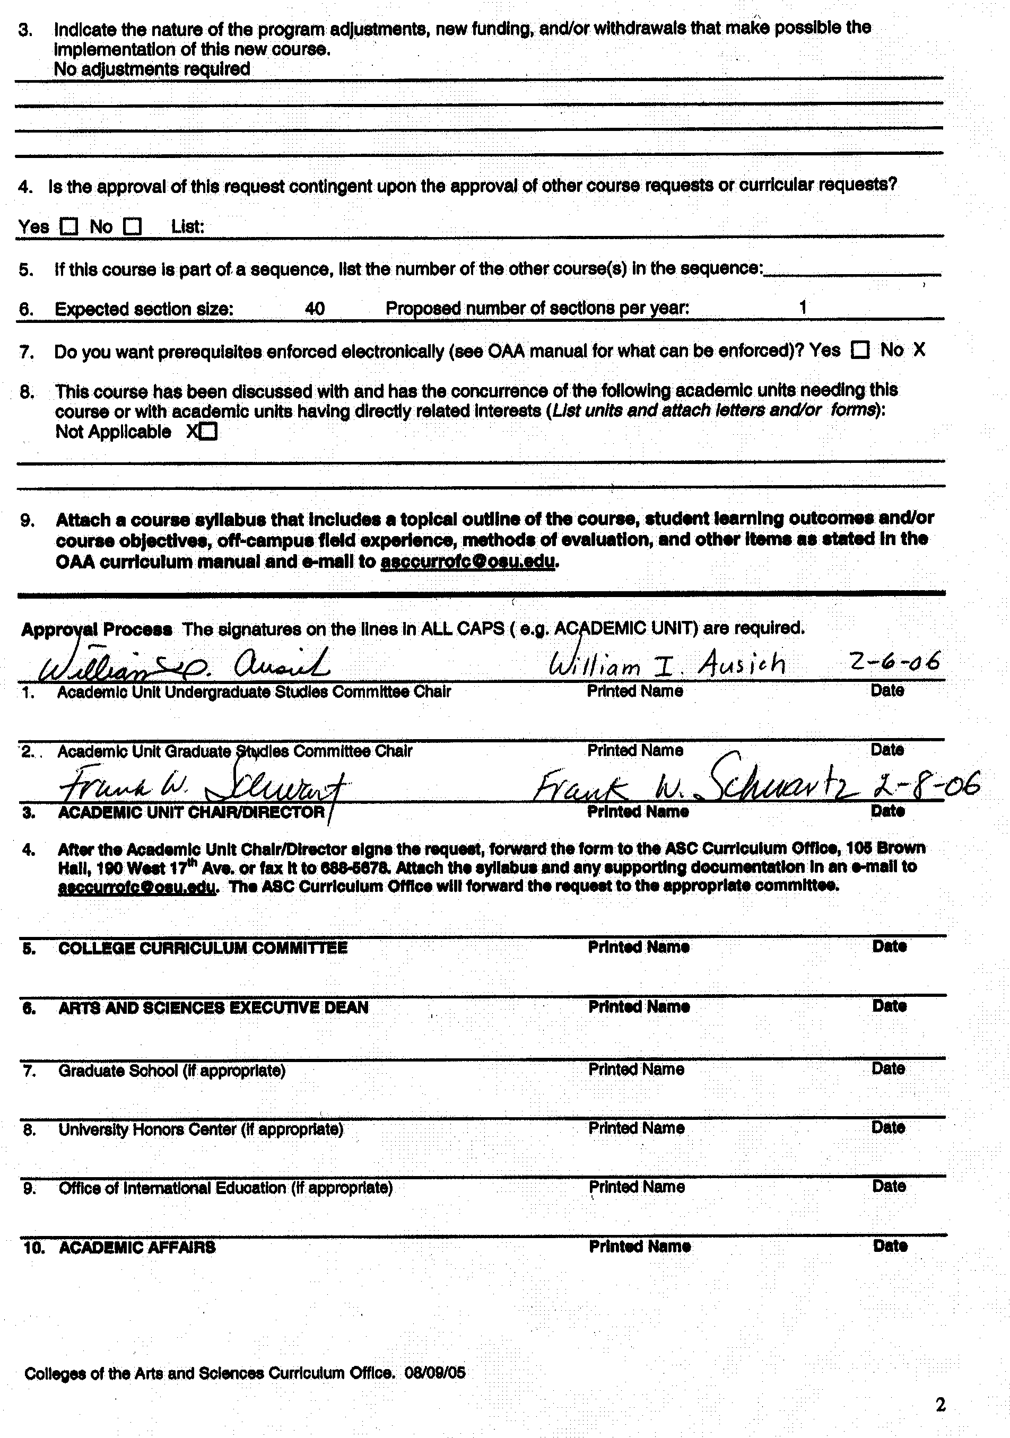

Dept of Geological Sciences 421

Peak Oil and Sustainability

Rationale: From a geological perspective, the pending shortage of fossil fuels, and most notably the decreased production of crude oil, may be of particular urgency. Few students realize that world oil production will peak during their life span, with predictions for the timing of “peak oil” ranging from 2005 to somewhere in the middle of the 21st century. Over the past century or so, economies of Western nations have developed explosively, fueled by cheap energy from fossil fuels. Decreased production and uncertain future production will likely lead to sharply rising prices for energy and may thus be expected to severely impact our economies – if not grinding our affluent lifestyles to a halt, as argued by some. In this class, we will explore these issues and attempt to separate rhetoric from facts, and how we can prepare for the inevitable: the last drop of cheap oil and gas.
This undergraduate level course on peak oil and sustainability will provide students with the basic foundation and broader perspective required for other courses in the geological sciences. Students outside the geological sciences will benefit from this introductory-level course by the development of an increased awareness of the issues surrounding fossil fuel consumption, and the viability of alternative energy sources. It is anticipated that enrollment for this course will grow steadily from less than 10, to 40 or more with increasing departmental and university exposure.

NEW COURSE SYLLABUS

College of the Arts and Sciences
Department of Geological Sciences
Course Number/Title: 421 Peak Oil and Sustainability

Instructor/Lectures: Dr. Kees van der Veen
Dr. Garry McKenzie

Graduate Teaching Associate: TBD

Required Text/Reading List: No required textbook; selected papers and sections from books will be placed on reserve or made available as part of a Cop-ez package.

Credit: 5 Credit Hours

Prerequisite: GEC data analysis course; sophomore standing and above

Course Structure: Two, 2-hour lectures and one, 1-hour recitation period/wk

Description: An examination of the problem of decreasing supplies of fossil fuels, alternative energy sources, and possible accommodations.

Content: The course will include group research projects and presentations plus assigned readings. Classes will explore the issues that are the result of decreasing fossil fuel supplies. It will attempt to separate rhetoric from facts and how we can prepare for the inevitable - the last drop of cheap oil and gas. Specific topics to be discussed include: the concepts of peak oil; oil uses; energy conservation; renewable and non-renewable energy resources; alternative energy sources, in particular, the controversy concerning hydrogen; the theory of Hubbert's peak - finite resources or unlimited wealth; and the future of suburbia. Global climate change and the demographics and dynamics of the world population explosion and resultant impacts on global energy resources will be evaluated to provide a broader perspective. Ultimately, students will address conjectural questions such as: “Will the transition from fossil fuels to a sustainable society with renewable energy sources be catastrophic?”; “Does the end of cheap energy mean the end of globalization and economic growth?”; and “What are the overall impacts on humanity of our present global energy policies?”.

Course Objectives: The primary objective of this course is to foster a broader, more comprehensive understanding of the global impacts of our present and projected fossil fuel consumption. Participating students will develop a critical awareness of the social, economic, and moral issues that must be addressed if sustainability is to be achieved with our present dependency on oil as the primary energy resource, and a nascent list of alternatives. It is hoped that students successfully completing this course will take the resultant knowledge beyond the classroom and become more informed and socially aware citizens and consumers.

Course Grades: Based on presentation (20%) and accompanying paper (30%), classroom discussion (20%), short paper and short presentation on pathways for future of society (20%), final exam --a one-page essay on a selected topic (10%).

Policies on Attendance and Absences: Attendance is required at all lecture sessions. The instructor should be notified as soon as possible in emergency situations where students must miss class. The deadline for make-up work for missed assignments, quizzes or examinations is one (1) week from the original date of administration. Each student must meet individually with the instructor regarding make-up work for missed assignments.

Disability Services: Students with disabilities that have been certified by the Office for Disability Services will be appropriately accommodated, and should inform the instructor as soon as possible of their needs. The Office for Disability Services is located in 150 Pomerene Hall, 1760 Neil Avenue (telephone 292-3307, TDD 292-0901, http://www.ods.ohio-state.edu/).

Academic Misconduct: The Ohio State University and the Committee on Academic Misconduct (COAM) expect that all students will complete all academic and scholarly assignments with fairness and honesty. Failure to follow the rules and guidelines established in the University’s Code of Student Conduct and this syllabus may constitute “Academic Misconduct”.
The Ohio State University’s Code of Student Conduct (Section 3335-23-04) defines academic misconduct as: “Any activity that tends to compromise the academic integrity of the University, or subvert the educational process”. Examples of academic misconduct include (but are not limited to) plagiarism, collusion (unauthorized collaboration), copying the work of another student, and possession of unauthorized materials during an examination. All suspected cases of academic misconduct will be reported to the University Committee on Academic Misconduct. If academic misconduct has been committed, possible sanctions could include a failing grade in this course and suspension or dismissal from the University.

Topical Outline: The following is a tentative, chronological outline of course lecture topics:

Week 1
Introduction and overview of course; geological perspectives on natural resources and fossil fuels; history of oil exploration in Midwest; and selection of research topic

Week 2
Hubbert’s Peak; indicators of oil resources; and projections of analysts.

Week 3
The energy mix for the world and USA; oil uses; and oil and the economy

Week 4
The future of suburbia; and per capita energy use in Europe and “the American Dream”

Week 5
Alternative energy options: solar and solar-derived

Week 6
Alternative energy options: geothermal and nuclear

Week 7
The hydrogen economy; and energy conservation options and impacts

Week 8
Other components of sustainability: population and global climate change

Week 9
Pathways for the future of society; and presentations

Week 10
Pathways for the future of society; and presentations

Final Exam:
One page scenario on related assigned topic.

